Copyright for test papers and marking guides remains with *West Australian Test Papers.*

Test papers may only be reproduced within the purchasing school according to the advertised Conditions of Sale.

Test papers should be withdrawn after use and stored securely in the school until Wednesday 11th October 2017.



**SEMESTER TWO**

**MATHEMATICS**

**SPECIALIST**

**UNITS 3 & 4**

**2017**

**SOLUTIONS**

***Calculator−free Solutions***

1. (a) 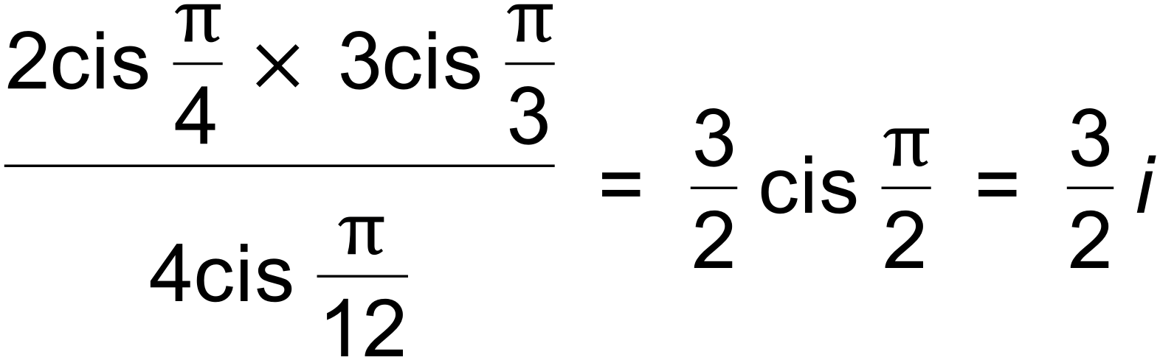 ✓

(b) 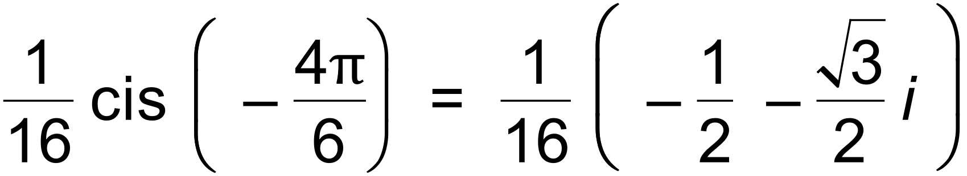 ✓

= 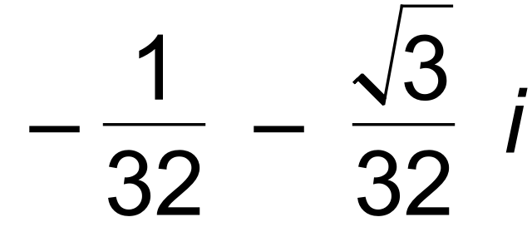 ✓

(c) 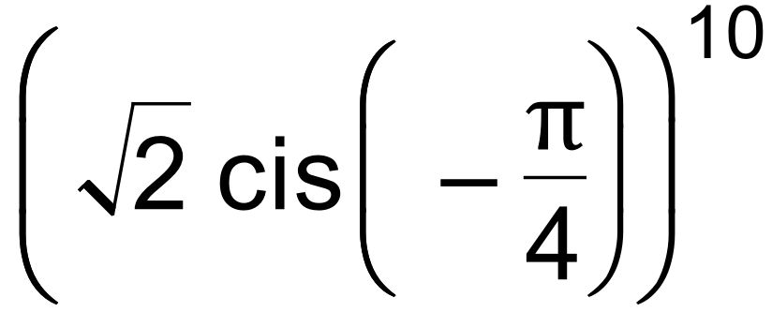 ✓

= 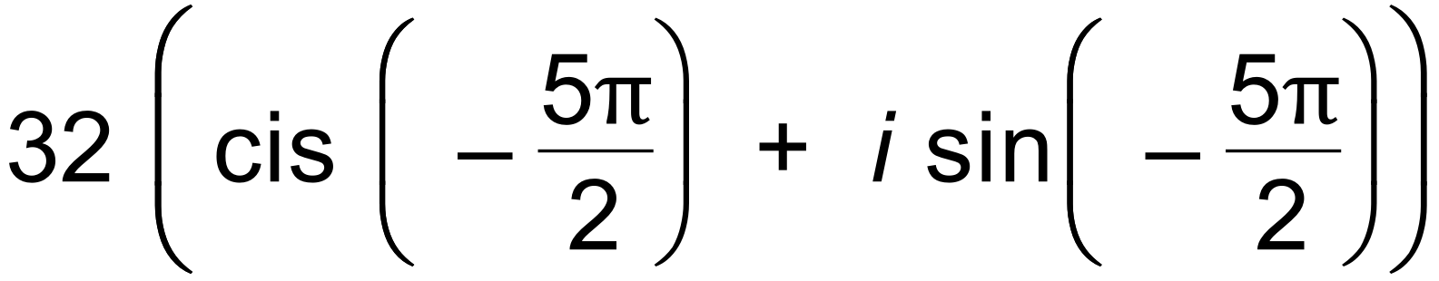 ✓

= 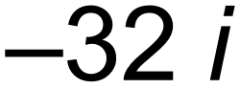 ✓ [6]

2. *f* (−3) = 0 so *z* + 3 is a factor

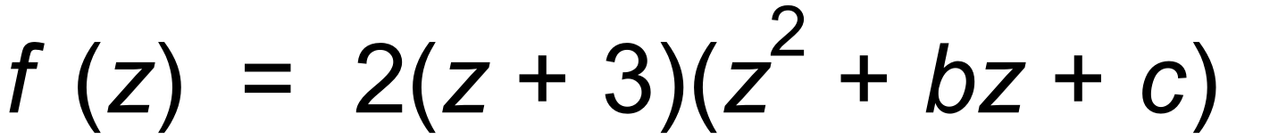 ✓

∴ *c* = 13 and *b* = −6 by equating coefficients or division

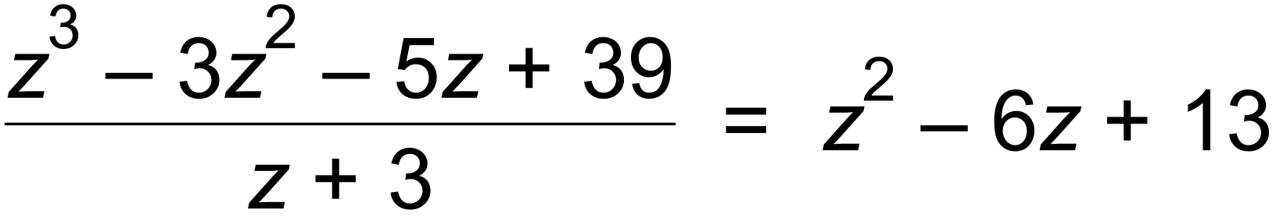 ✓

∴ 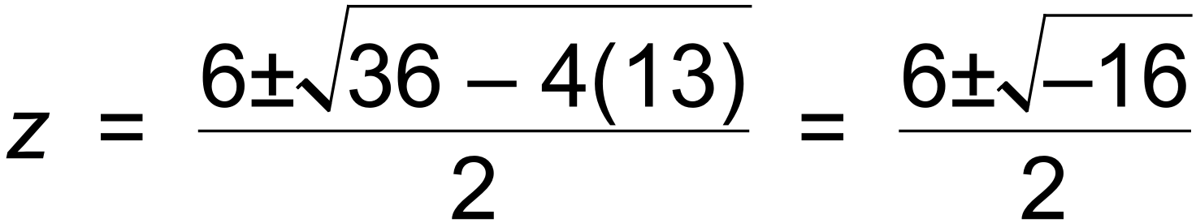 ✓

∴  ✓ [4]

3. 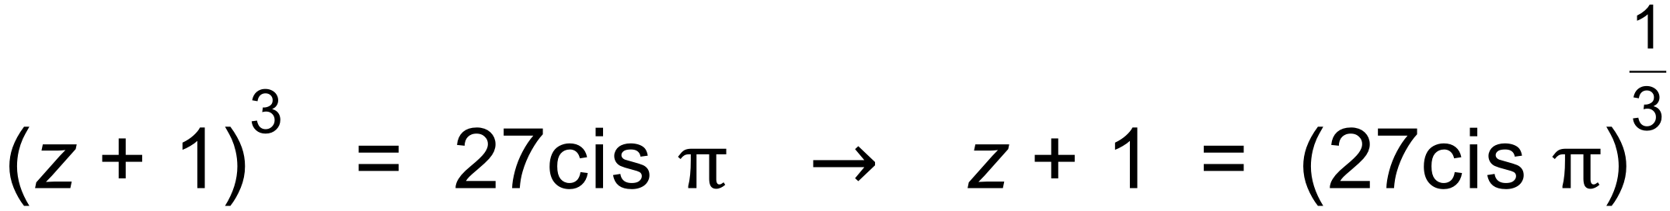 ✓

∴ 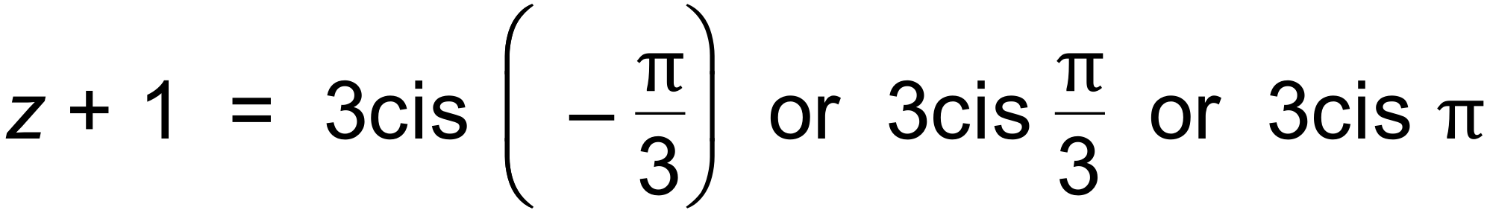 ✓✓

∴ 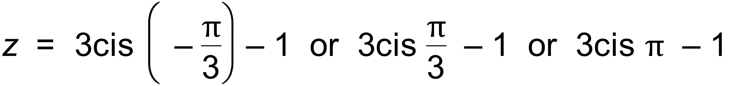 ✓ [4]

4. (a) 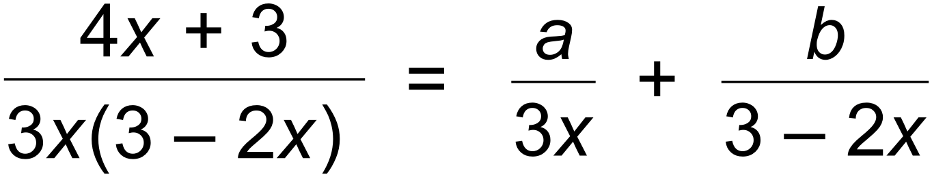 ✓

∴ 

∴  ✓

∴ 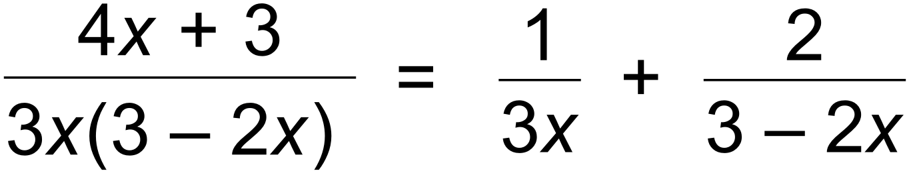 ✓

(b) 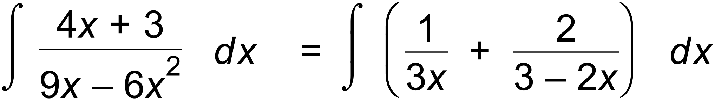 ✓

= 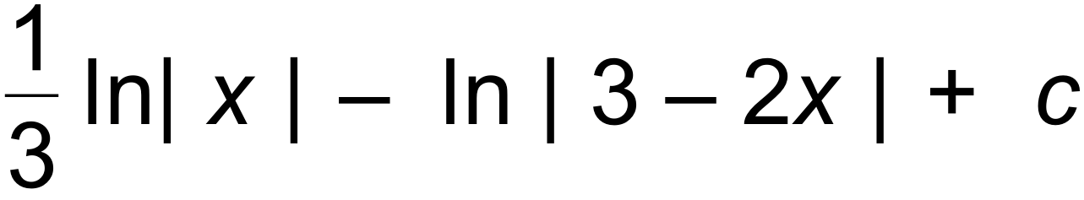 ✓✓ [6]

5. (a) 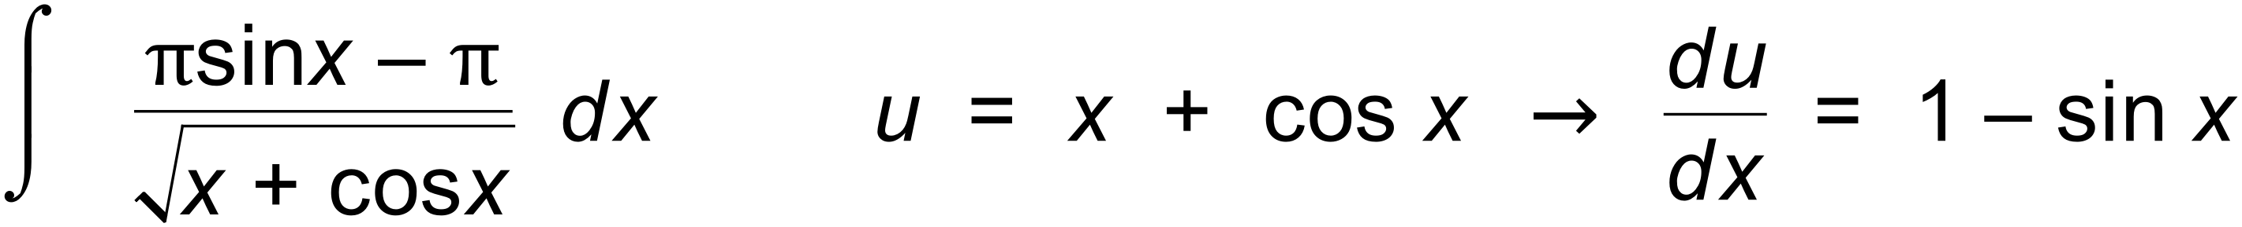 ✓

= 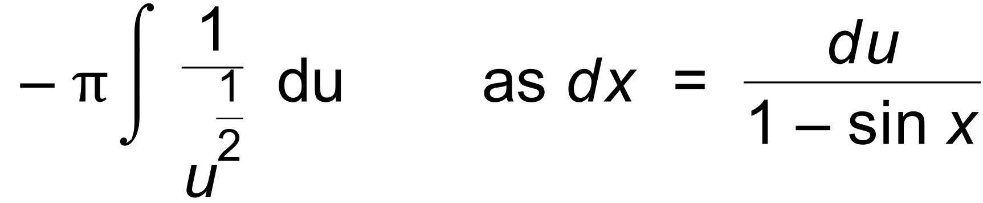 ✓

= 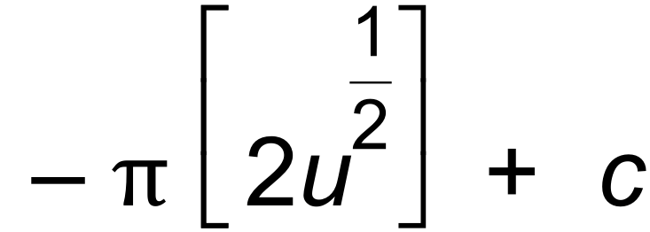 ✓

= 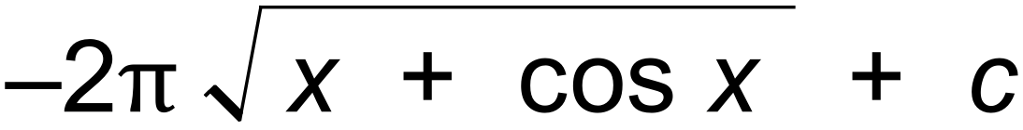 ✓

(b) 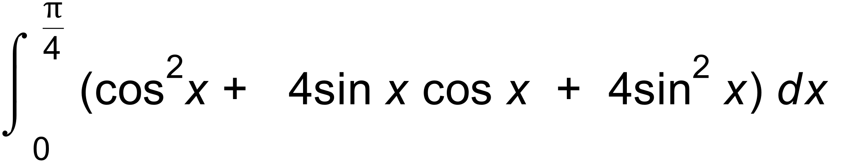 ✓

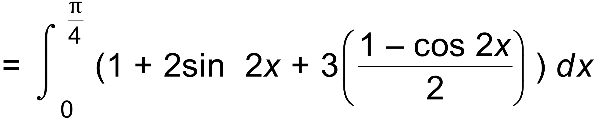 ✓

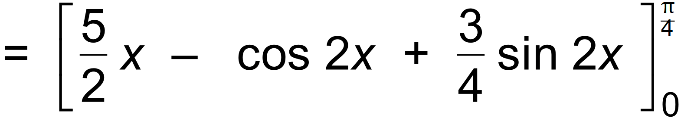 ✓

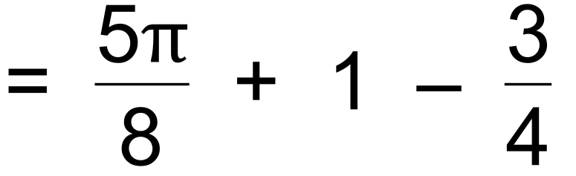

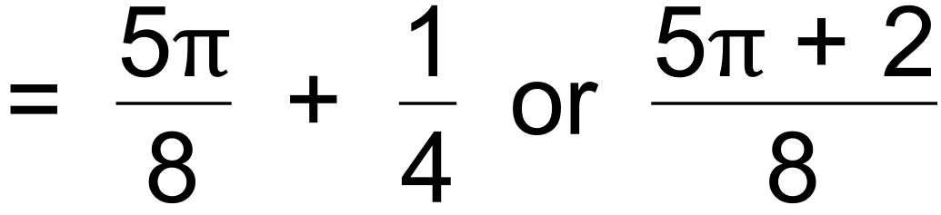 ✓ [8]

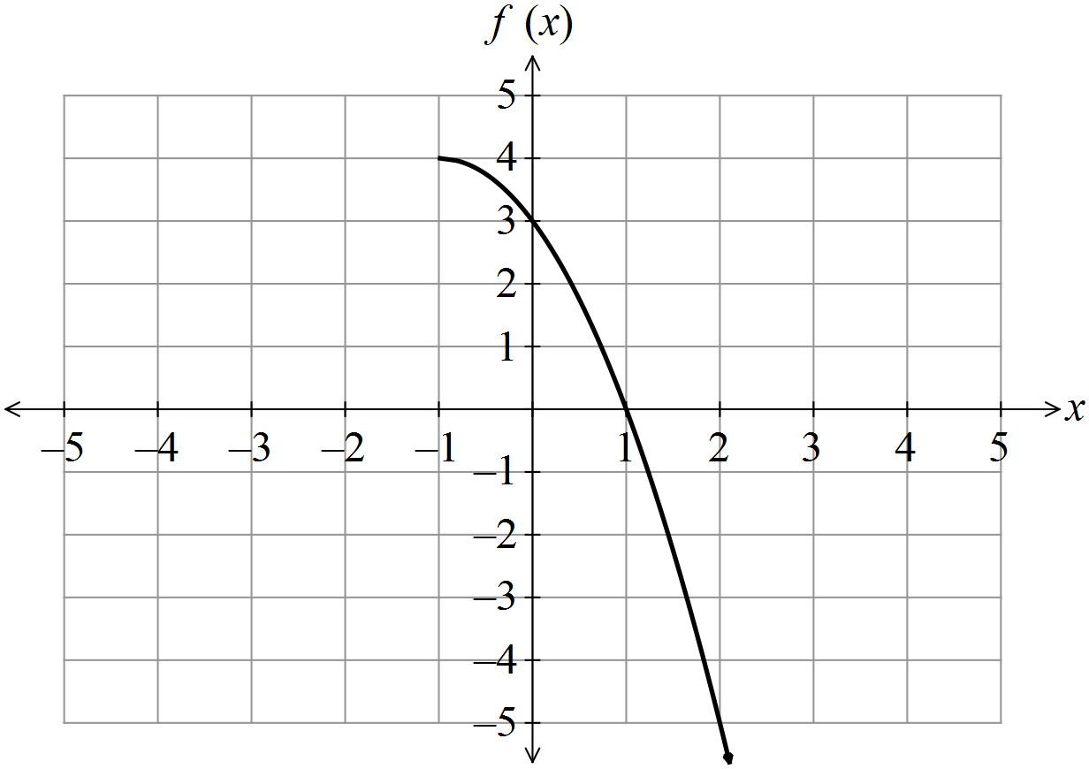6. (a) (i)

✓

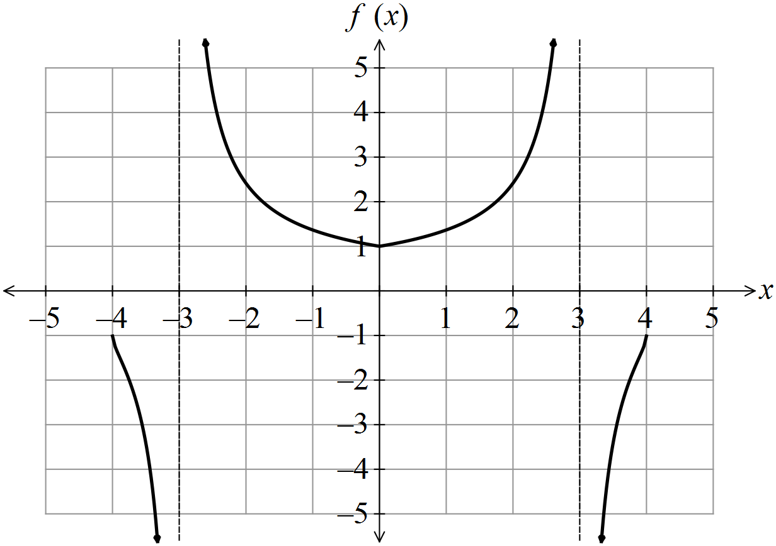 (ii)

✓✓✓✓

(b) 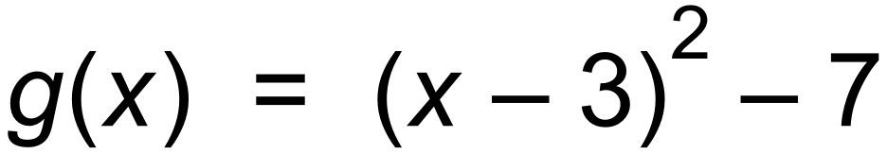 by completing the square ✓

So domain of *g* (*x*) will be 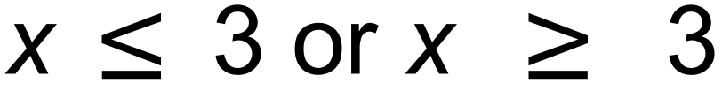 (max allowable

for *g* and to have an inverse)

∴ 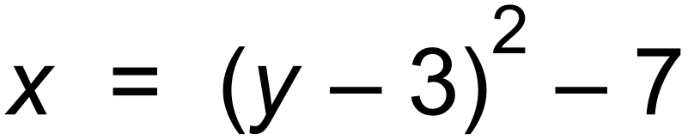 ✓

∴  ✓ [8]

7. (a) (i) 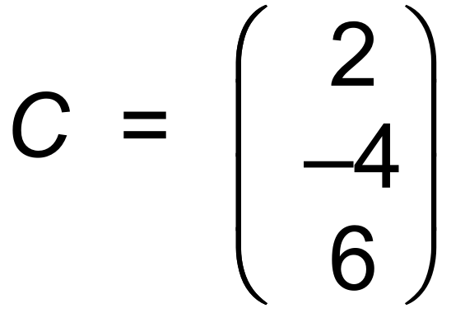 ✓

(ii) A and C ✓

(iii)  ✓

(iv) 

Since < 49, then inside ✓

(b) 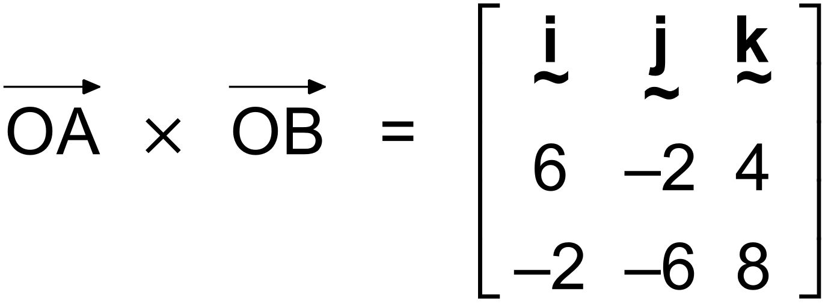

=  ✓✓

Or any other vector parallel to 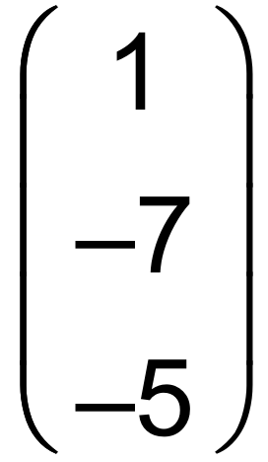 [6]

8. (a) 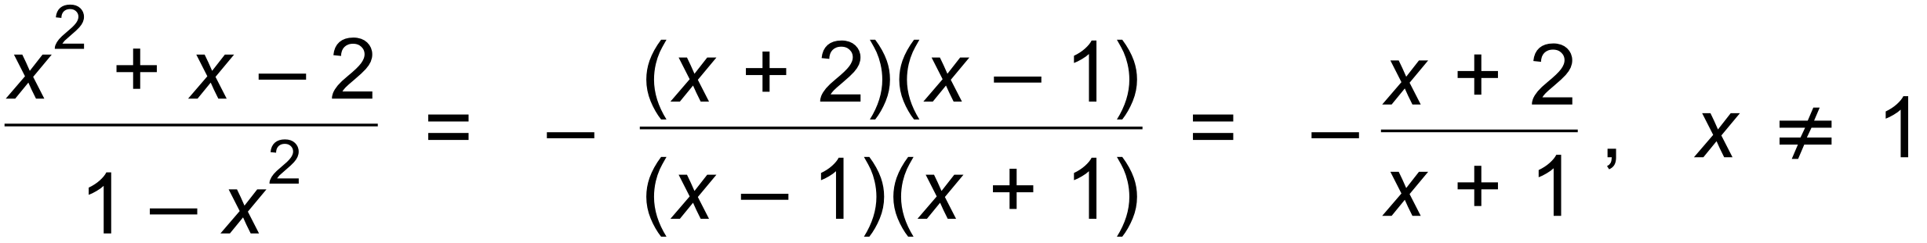 ✓

∴ *x* = −1 is vertical asymptote and *x* = 1, (1, −1.5) is a hole. ✓✓

 ✓

*y*−intercept = −2 and *x*−intercept = −2 ✓

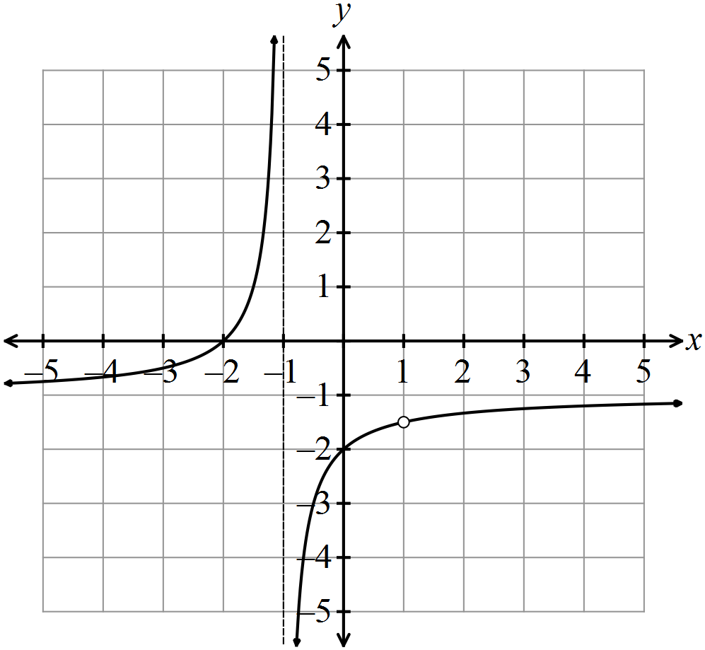 (b)

✓✓✓ [8]

***Calculator−assumed Solutions***

9. (a) 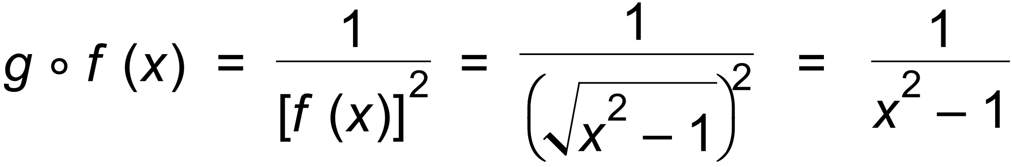 ✓

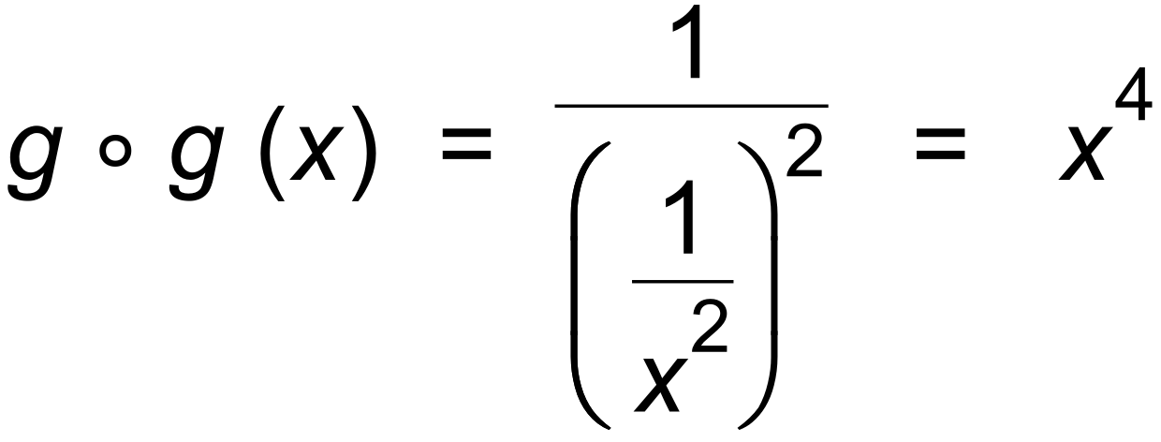 ✓

(b) (i)  ✓✓

(ii) y > 0 ✓

(c) 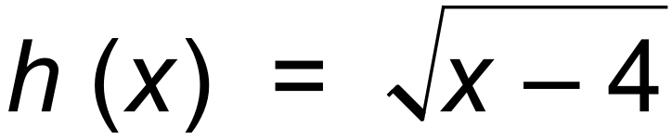 ✓ [6]

10. (a) | *z* − (−1+2i) |  is the region inside the circle centre (−1, 2) and radius 1

| *z* + i |  | *z* − (2 + i) | is the region on one side of the line *y* = −*x* + 1,

containing (1, 1)

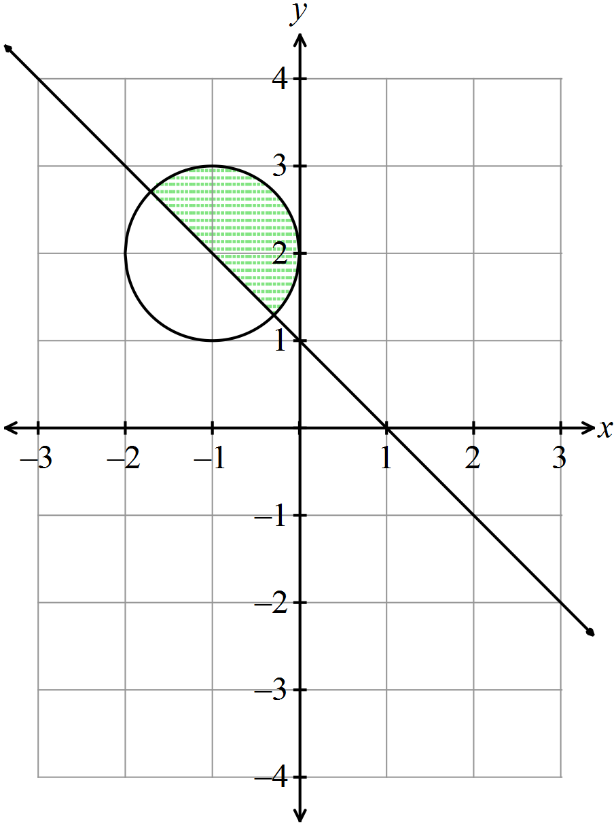

✓✓✓✓

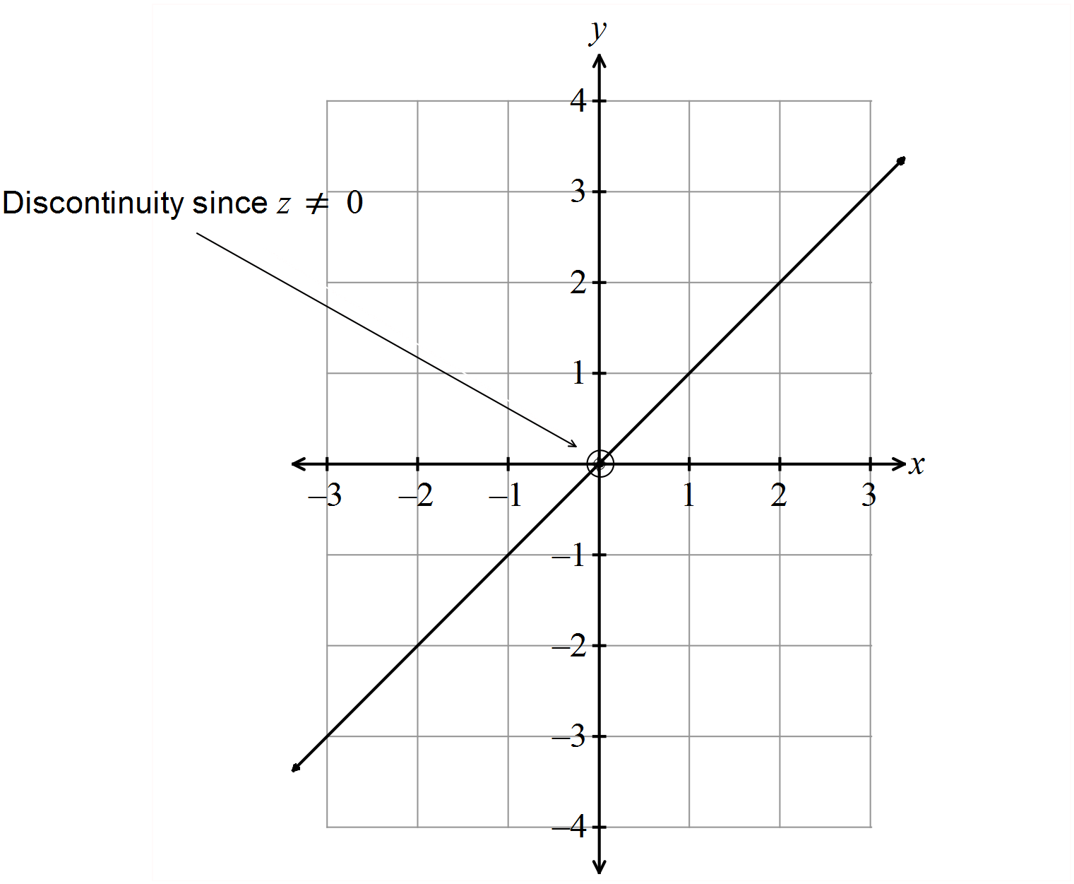 (b) 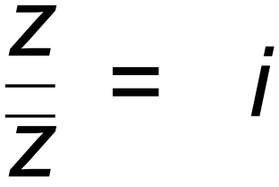 is the line *y* = *x*, since *x* + *y*i = i(*x* − *y*i) = *y* + *x*i

✓✓

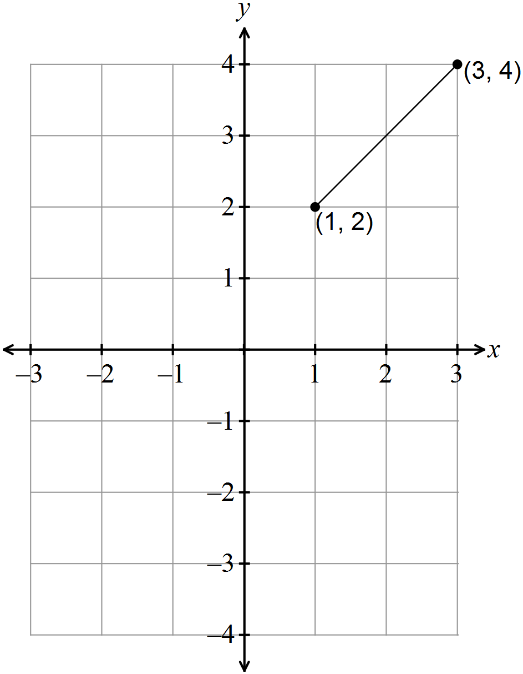 (c)

✓✓ [8]

11. (a) 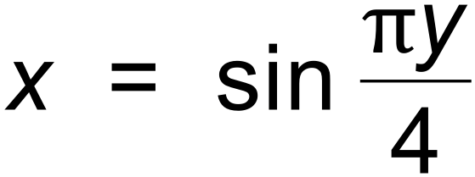

∴ 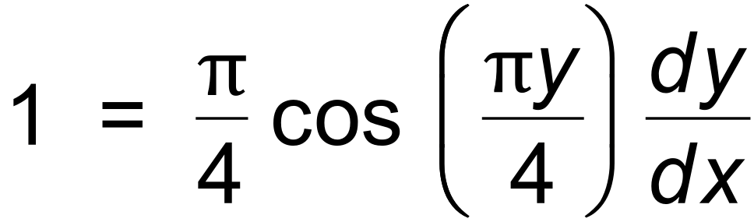 ✓

∴ 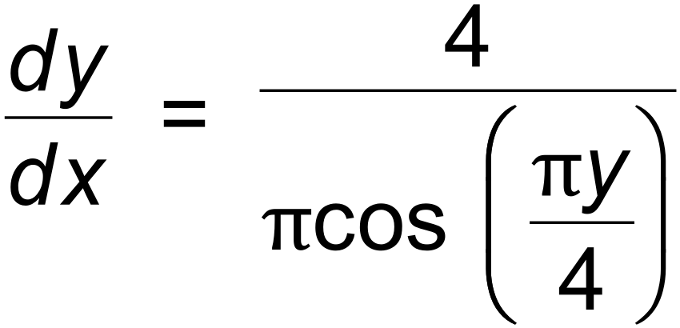 ✓

(b) 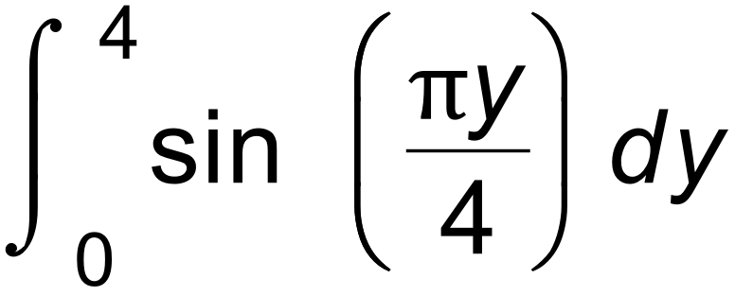 ✓

= 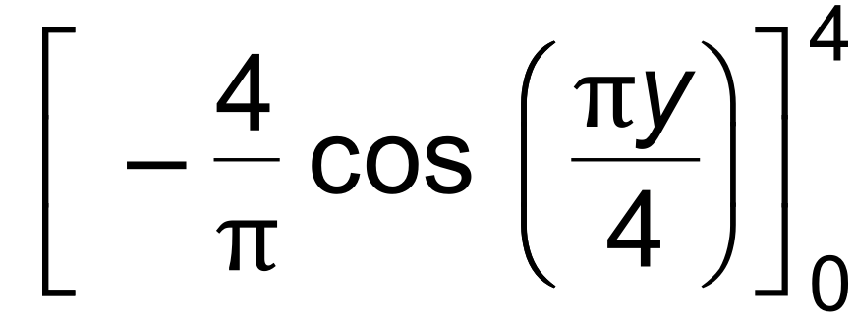 ✓

= 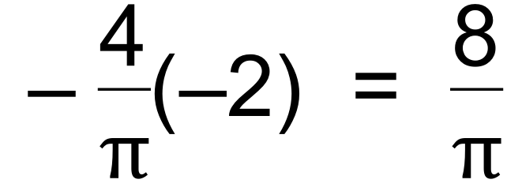 ✓ [5]

12. (a) 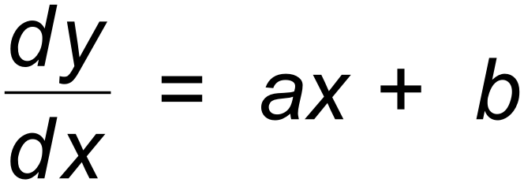 where *a* > 0 ✓

Since  ✓

∴ 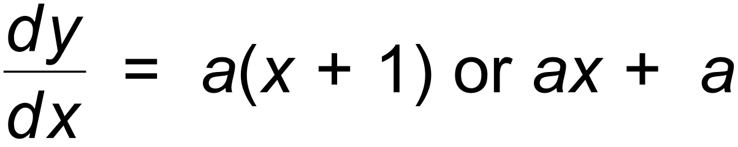 ✓

(b) 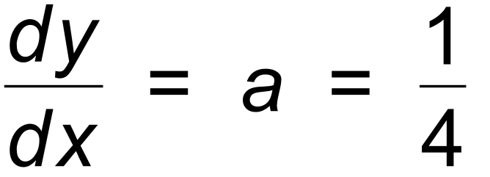 when *x* = 0 ✓

and 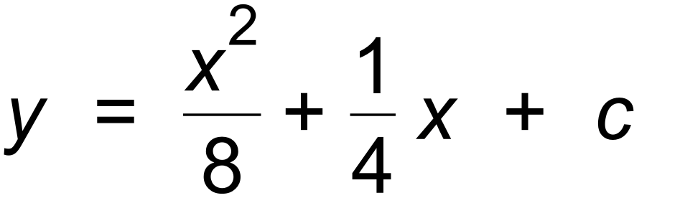

∴ 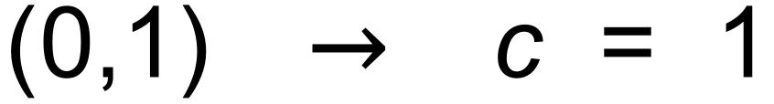 ✓

∴ 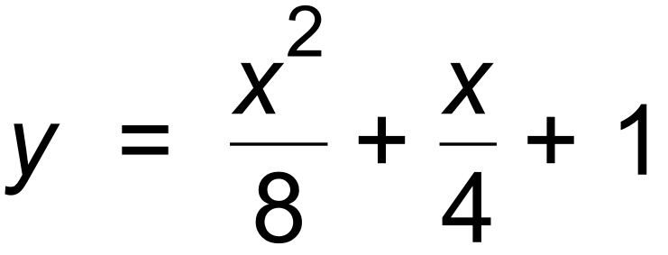 ✓ [6]

13. (a) 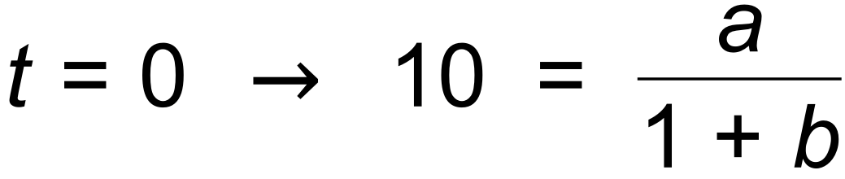

∴ 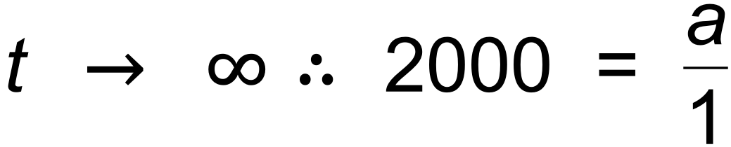

∴ *a* = 2000 and *b* = 199 ✓✓

(b) Increasing at greatest rate at oblique point of inflection.

∴ 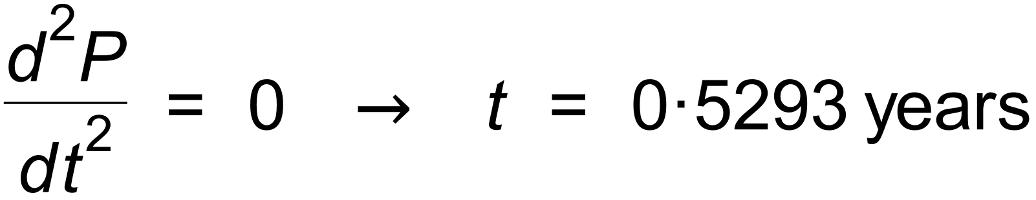 and *P* = 1000 ✓✓✓ [5]

14. (a) 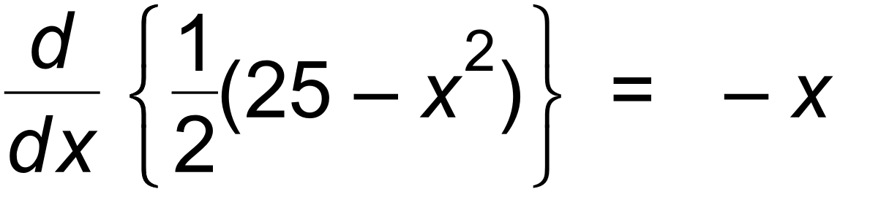 ✓

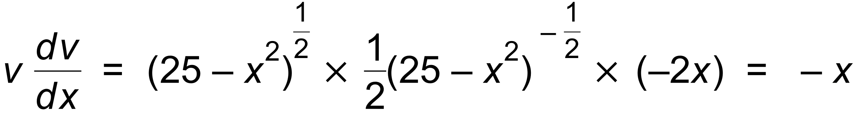 ✓

(b)  ✓✓

(c) 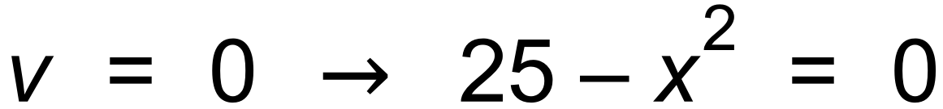

 ✓✓

(d)  ✓✓ [8]

15. 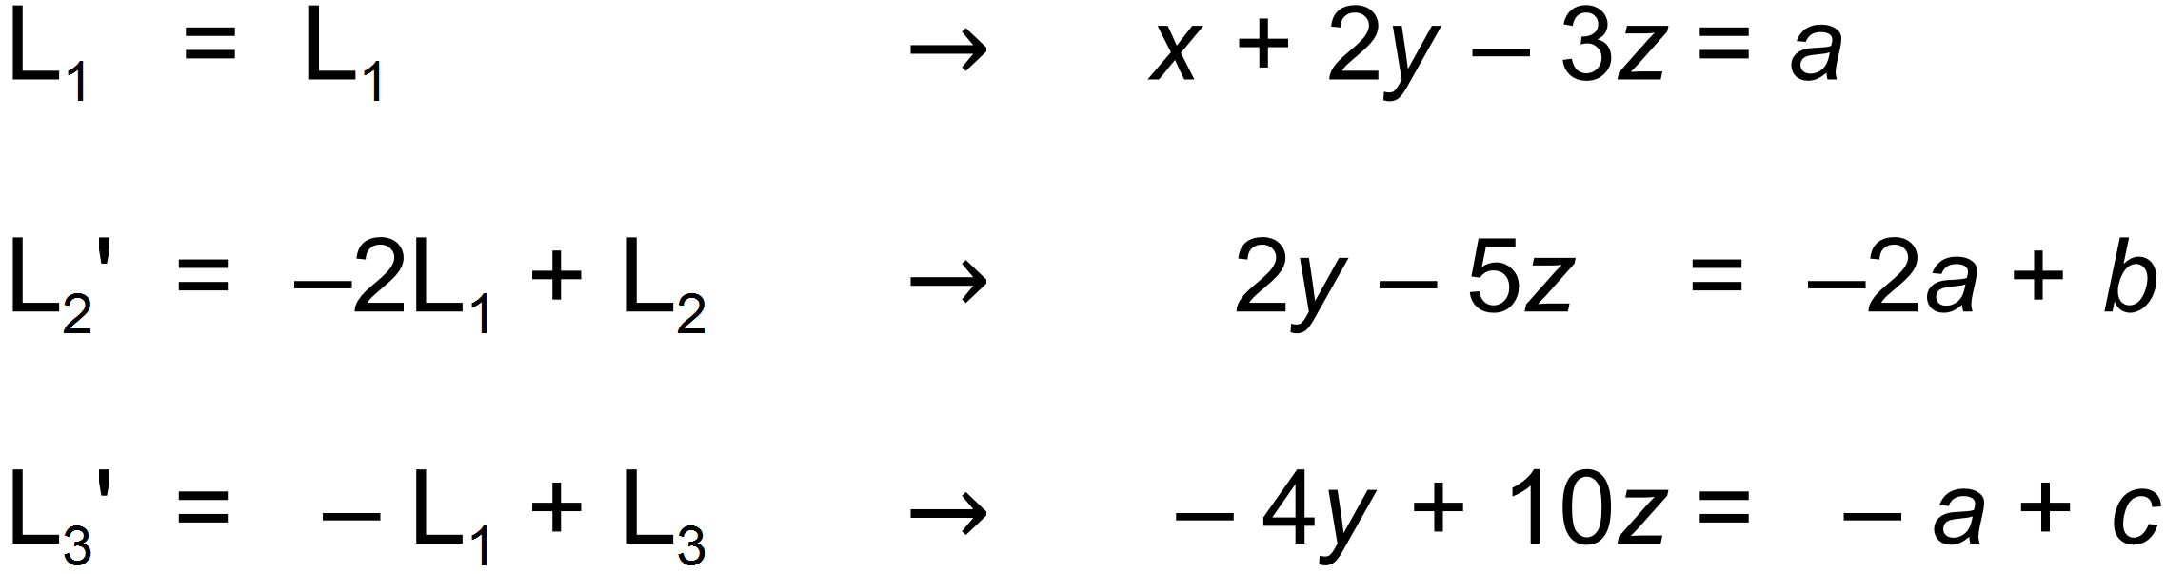

✓

and then

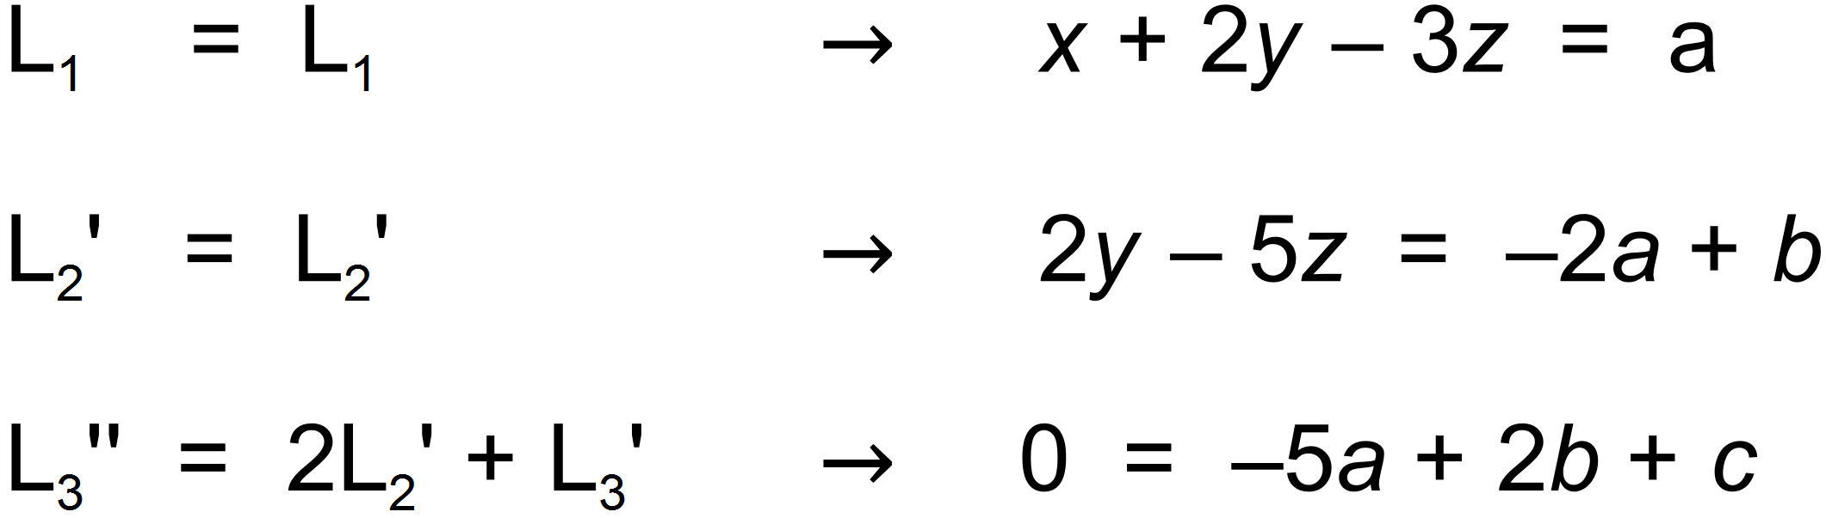

✓

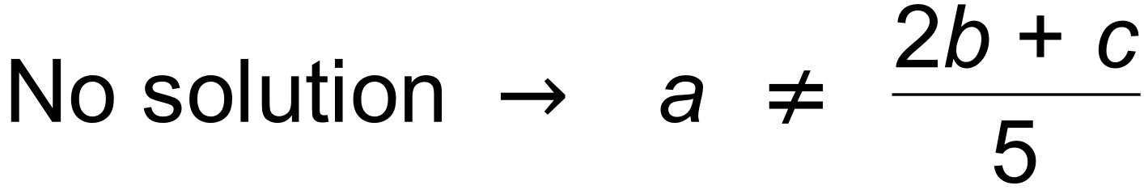 ✓✓ [4]

16. (a) 

∴ 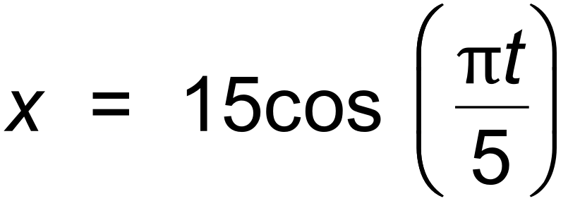 ✓✓

and 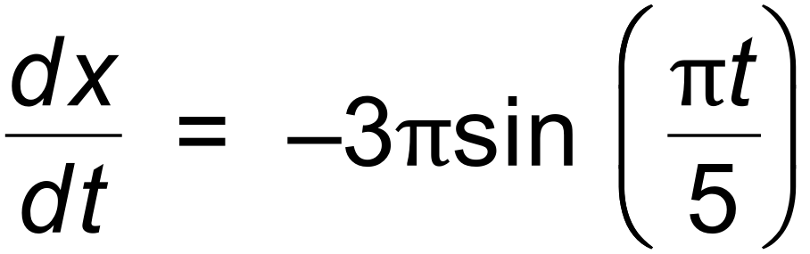

∴ Max speed = 3 m/sec ✓

(b) 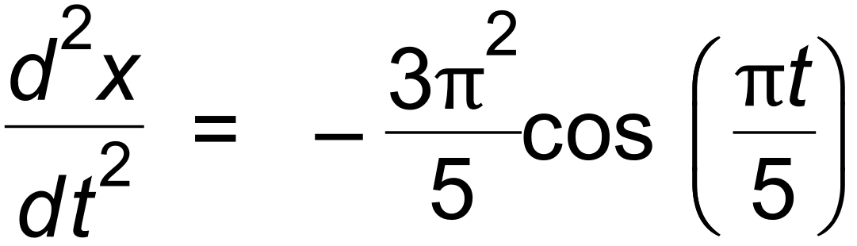

∴ Min acceleration = 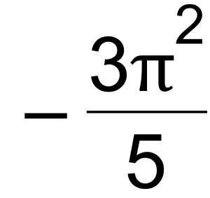 m/sec2 is at *x* = 15 m ✓✓ [5]

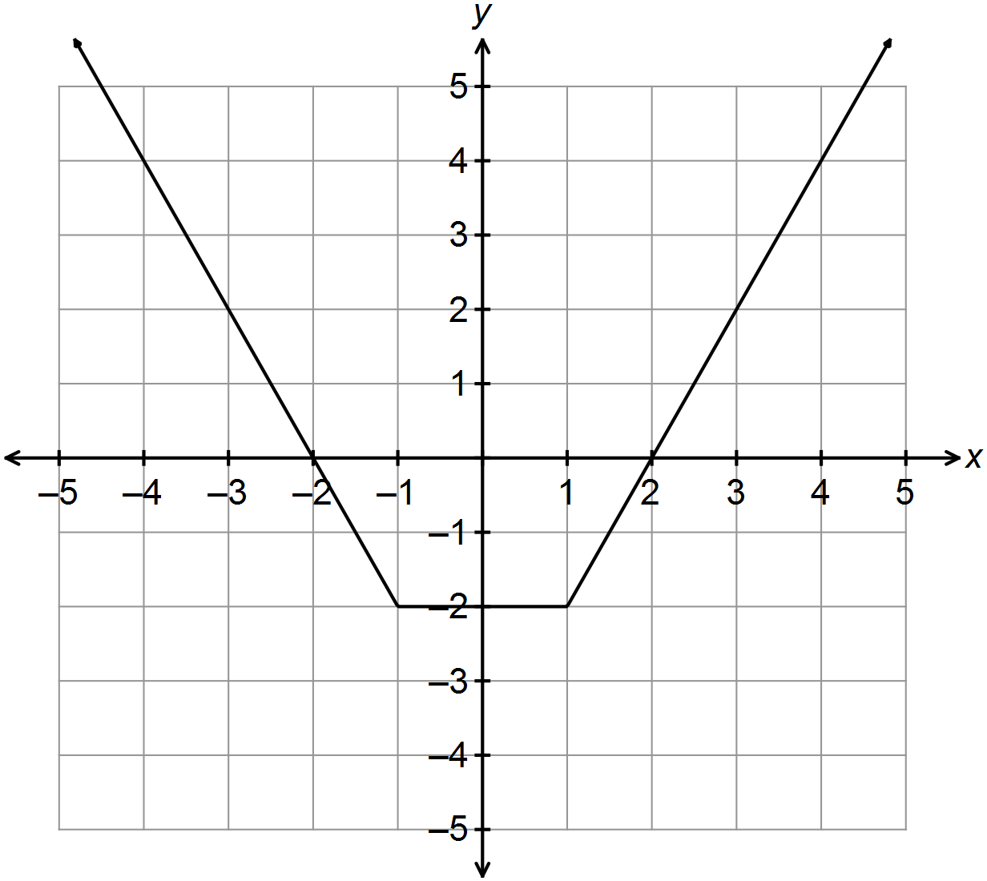17. (a)

✓

(b) *a* = 1 ✓

*b* = 2 (or −2) ✓

*h*(0) = 4 − *c* = −2 ∴ *c* = 6 ✓

(c) *d* > −6 ✓✓ [6]

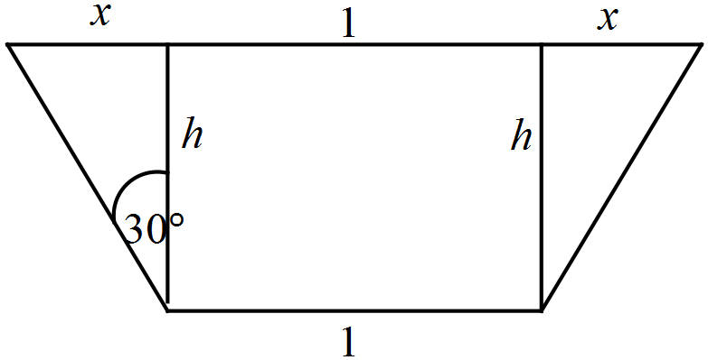18. (a)

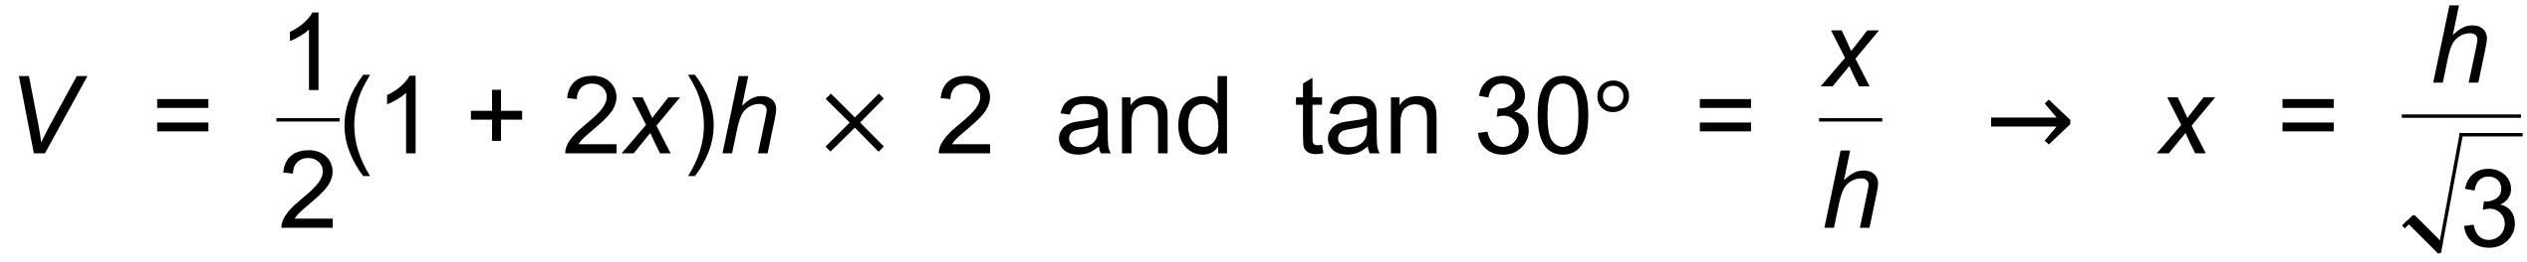 ✓

∴ 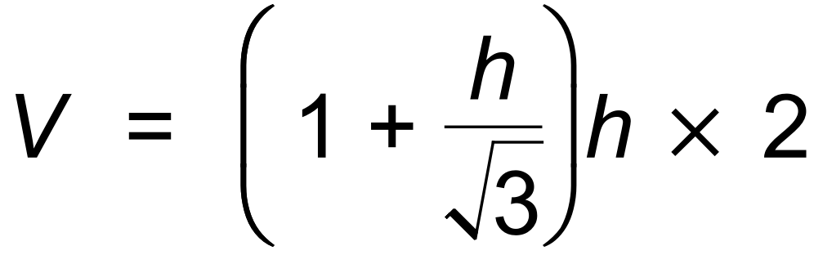 ✓

∴ 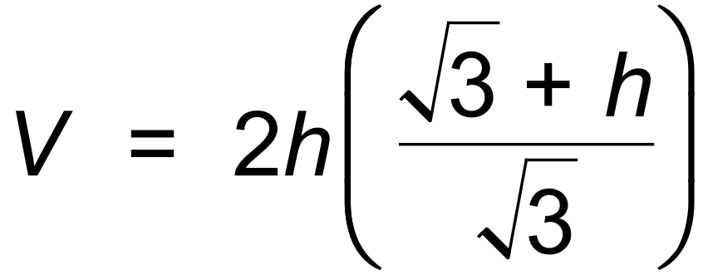 ✓

(b) 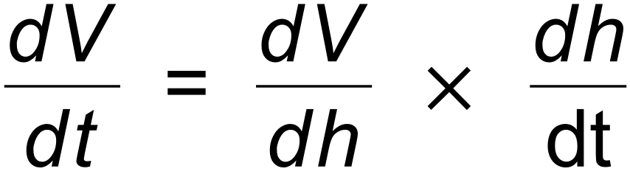 and 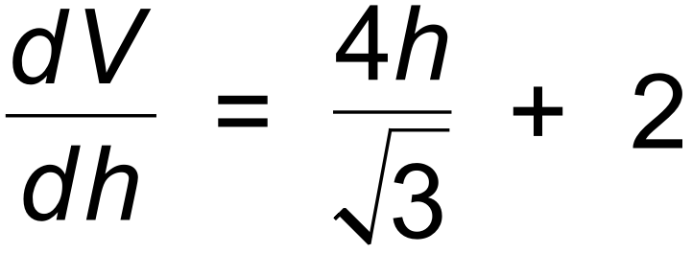 ✓

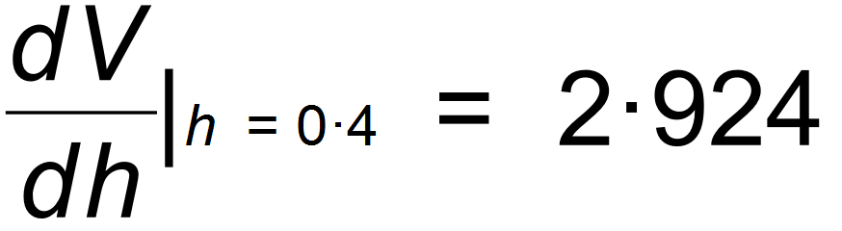 ✓

∴ 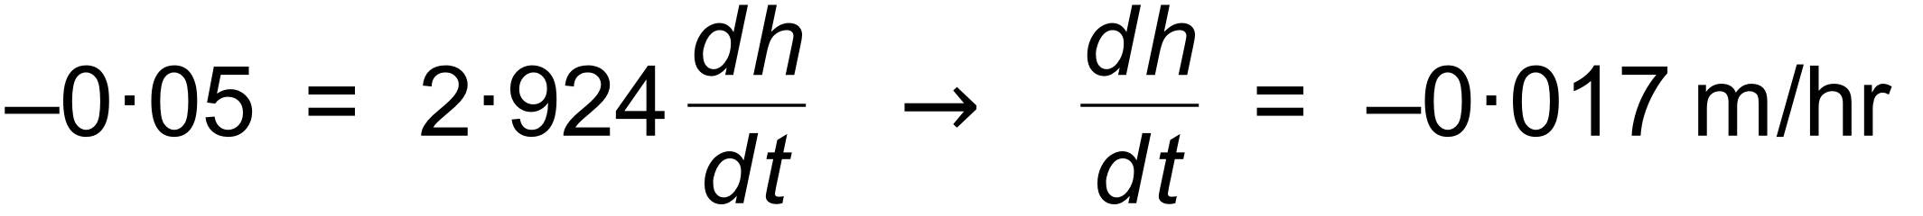 ✓

(c) 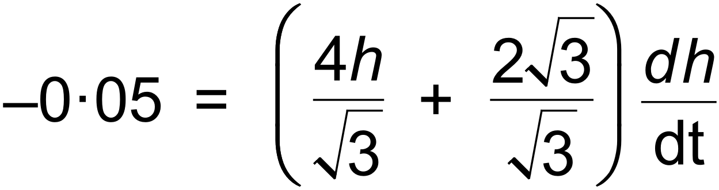 ✓

∴ 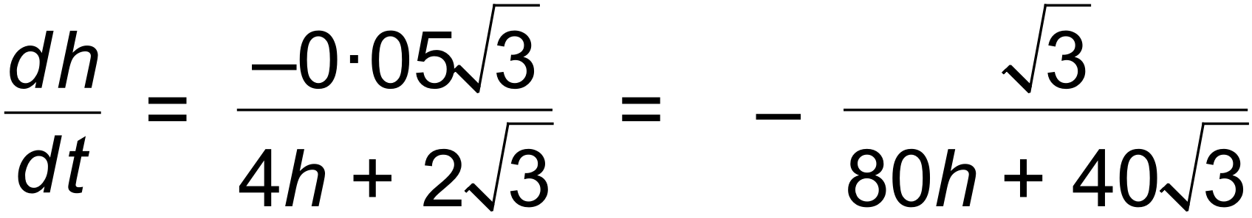 ✓

(d) 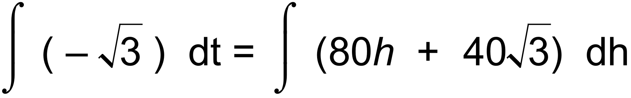

∴ 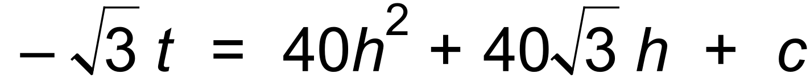 ✓

Since 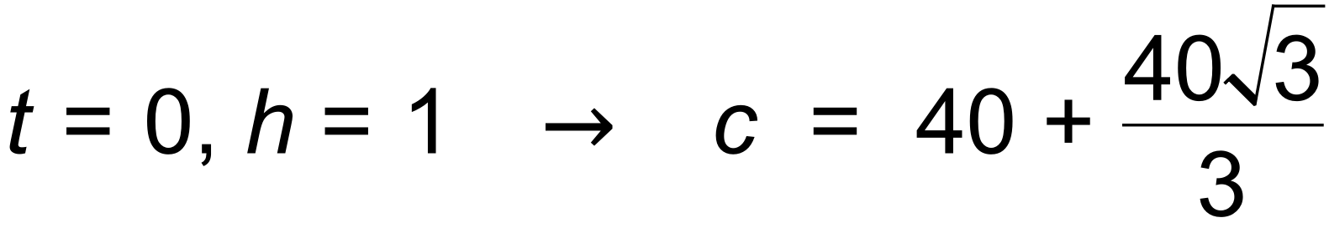 ✓

∴ 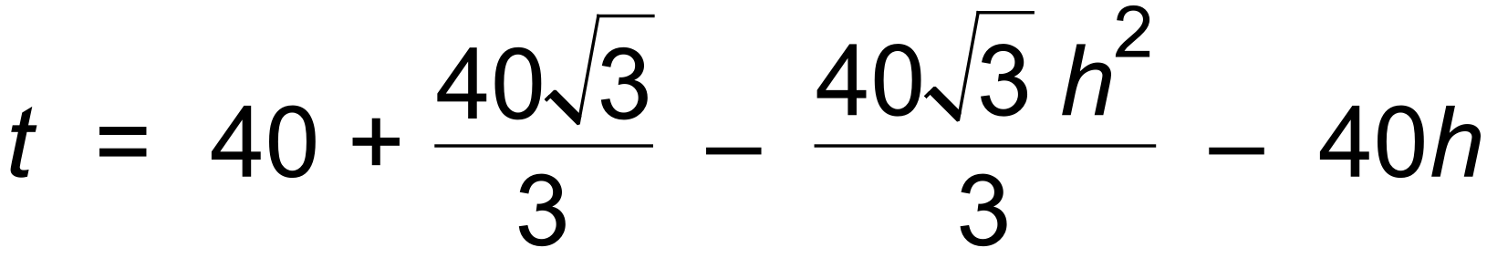 ✓ [11]

19. (a) (i) 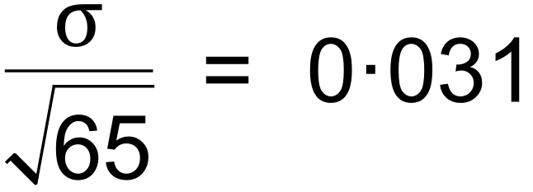 ✓

∴  ✓✓

(ii)  ✓

∴ 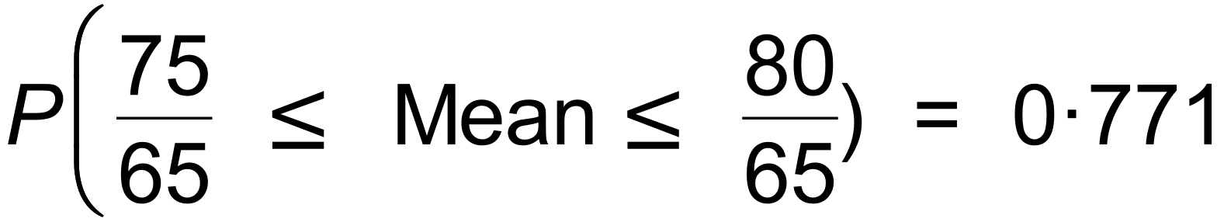 ✓✓

(b) 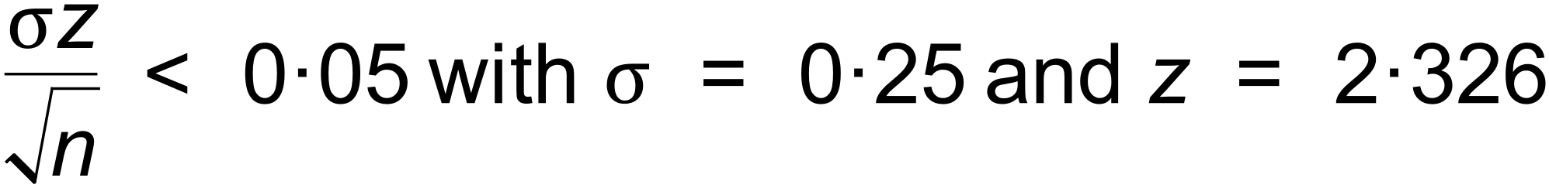

∴ 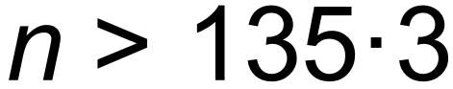 ✓

∴ Need to catch 136 fish. ✓

(c) 

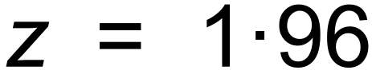

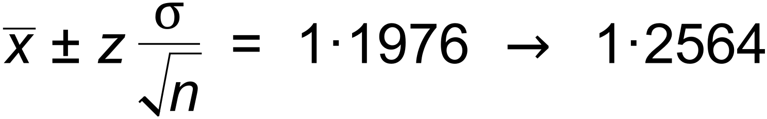 ✓✓

∴  ✓

∴ Cannot conclude that crayfish in James’ area are

significantly bigger ✓ [12]

20. (a) 

∴ 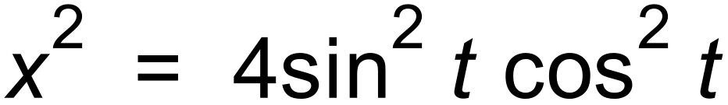 ✓

∴ 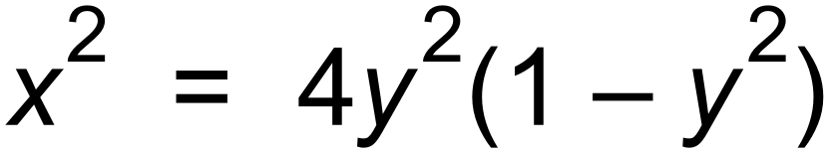 ✓

(b) 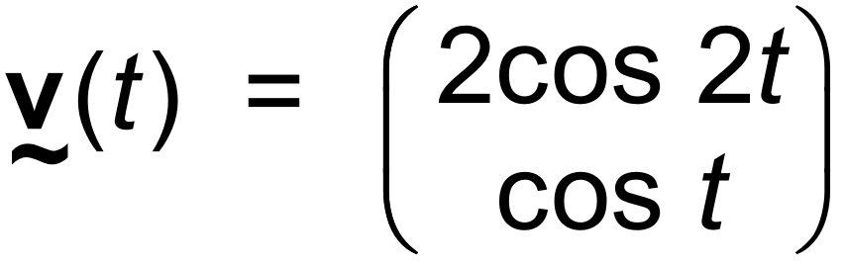

∴ 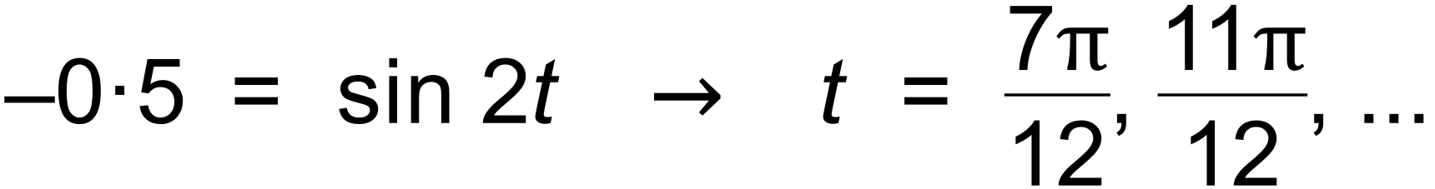 ✓✓

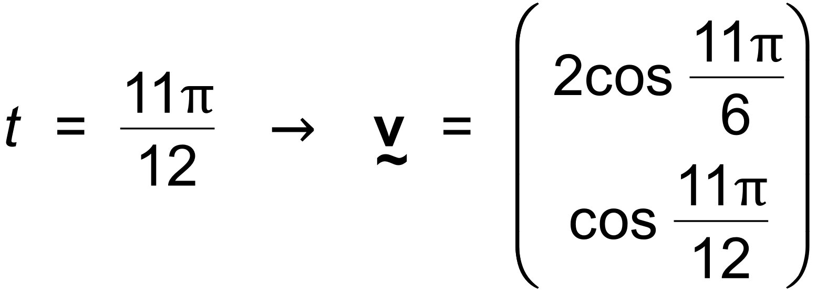 ✓

∴ Speed = 1.98 m/sec ✓

(c) 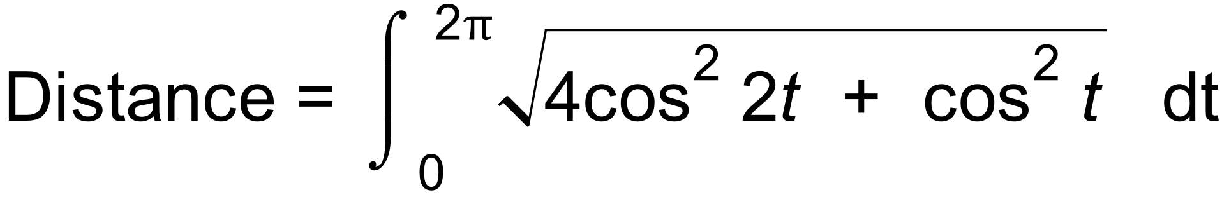 ✓✓

= 9.43 m ✓ [9]

21. (a) 

∴ *k* = 6 ✓✓

(b)  ✓ 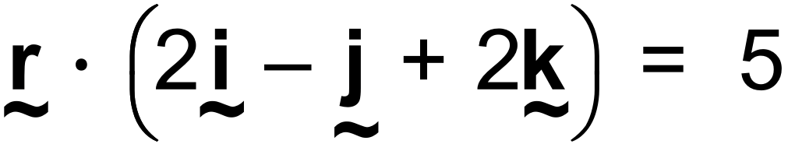 ✓

(c) 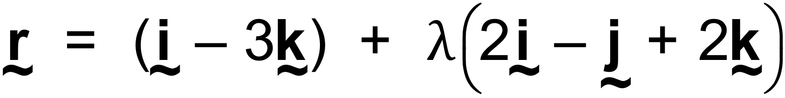 ✓ (d)  The distance from A to each triangle has a scale of 1:3 ✓ ∴  ✓ (e)  ✓

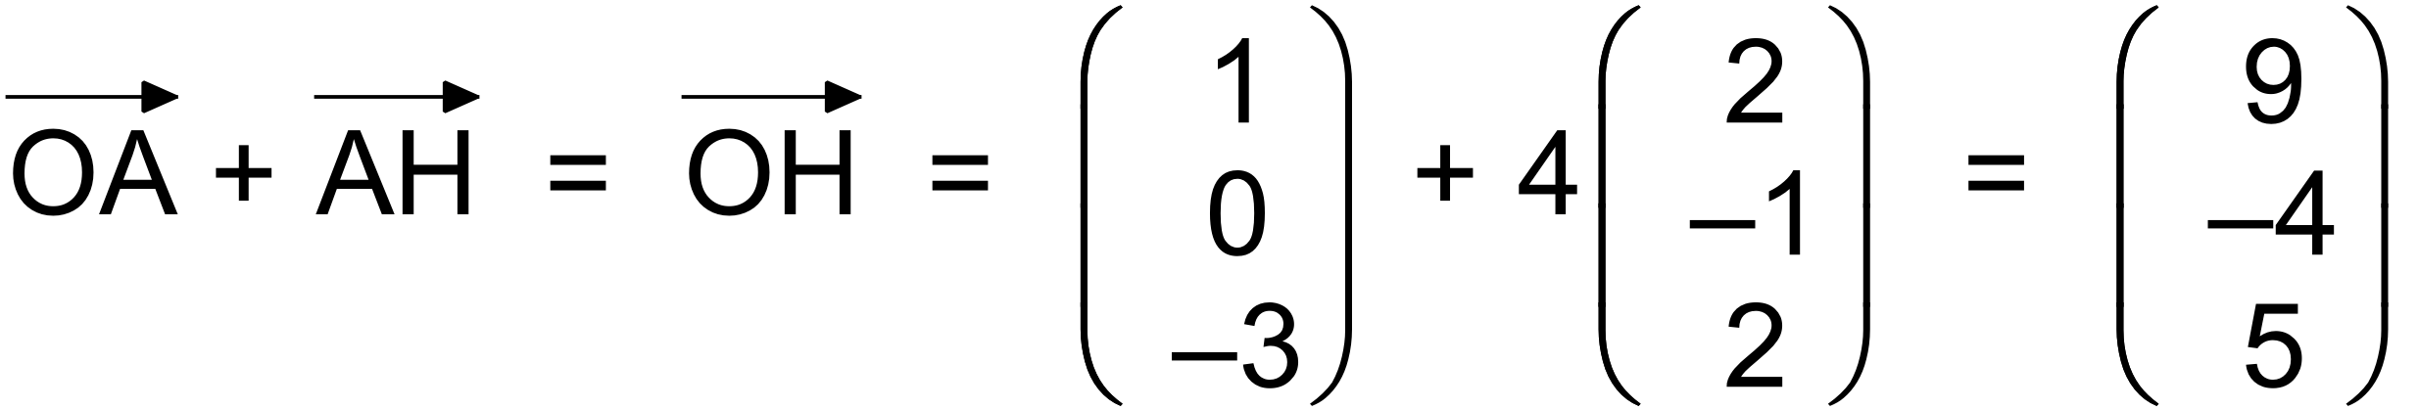 ✓

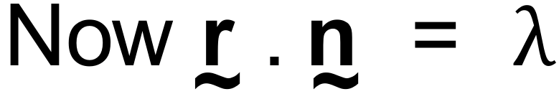

∴ 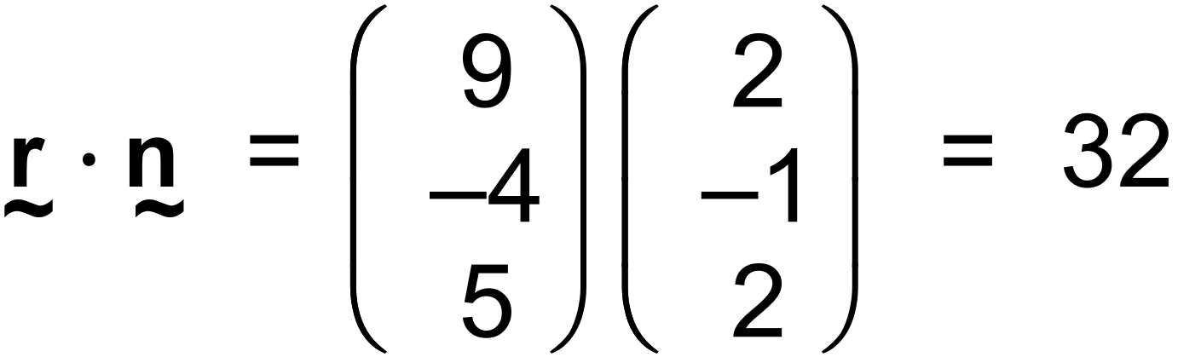

∴ 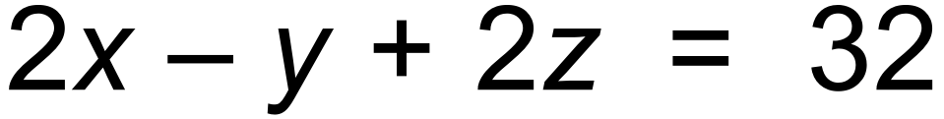 ✓ [10]

22. (a) 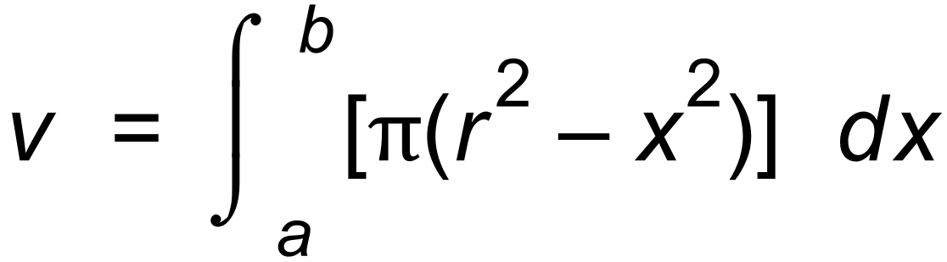 ✓

(b) 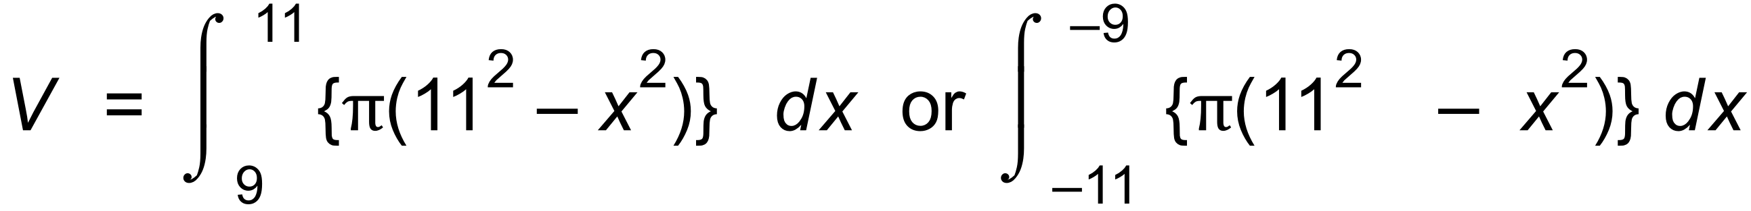 ✓

= 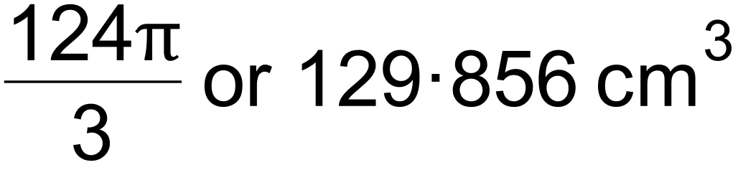 ✓

(c) 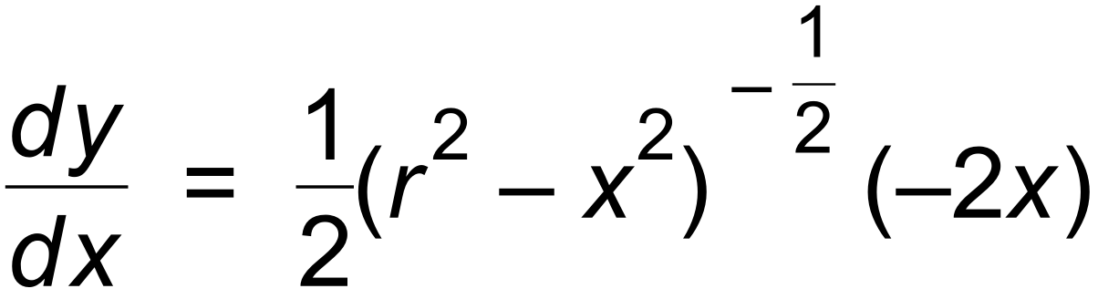 ✓

∴ 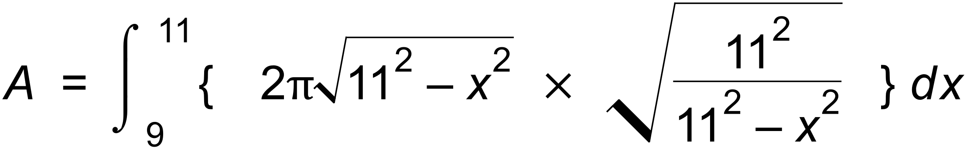 ✓ [5]